Leehe Mahalal; Pompano Beach High School

Jessica Pan; Stoneman Douglas High School

Dalton Poe; Hallandale High School

Gizmo City App Research Paper

Abstract

The first section of our paper is our Background, wherein we discuss what the physical Gizmo City exhibit is like, and why we chose it as the subject of our Android application. Following the Background section is Methods, wherein we each discuss our role in the creation of our application and the methods that we employed in order to achieve the final product that we have today. In the Results section, there are photographs of our application’s key features, and in-depth explanations of each of Gizmo City’s activities and the purpose that they serve. In Discussion, we reflected upon the current state of our application and ventured into the future of the application; we realized that the puzzles category held the most potential, as its timers and hints bear tremendous possibility. Succeeding Discussion is our Acknowledgments section, in which we give thanks to each of the individuals and institutions that made the creation of our application possible. In our References, we referenced the websites and programs whose content was indispensable in the creation of our Gizmo City application.

Background

We chose Gizmo City as our exhibit during the APP-titude internship at the Museum of Discovery and Science due to the plethora of interesting tidbits of information that had been left without explanation, and because of the intriguing puzzles that were found within the section. Many of the puzzles were complicated, and hard to solve, which left our group with the idea of providing an easier way of solving each puzzle, and potentially improving the museum’s visitors’ experience when checking out Gizmo City. Plenty of the informative exhibits were left without plaques that related them to science, such as the human hurricane, racing balls, and giant lever, which gave us the opportunity to insert that into our application as well in order to increase the educational potential of Gizmo City. The internship provided many opportunities over the course of a year for our group to do the research on our respective area, and we had gained a surplus of insightful information and elements that ended up implemented into the app. Due to our familiarity with the area, creating the app sections and theme became much more straightforward, for we already knew what the main elements of our app would be.

Methods

During the creation of our application for Gizmo City, we assigned our roles of graphic designer, Java programmer, and User Interface lead based on the ability of each member. Jessica was assigned as the Java programmer due to her experience with taking AP Computer Science in the past, Leehe was assigned graphic designer due to her experience with photoshop, and Dalton had been assigned to User Interface due to his interest in both design and programming. Leehe had the responsibilities of designing every graphic and taking every picture that had been put on the app, such as backgrounds, titles, icons, buttons, exhibit pictures, hint pictures, and solution pictures. All of this had been done through the usage of photoshop, along with google images and google design, which provided fantastic content and lessons on the essentials of design. Originally, when there had been a problem with sizing, Leehe had been the one to test out multiple sizes of every button, title, or picture, along with the positioning with every background to fit it all in as well. As the UI developer, Dalton had the responsibilities of ensuring that each of the buttons, pictures, titles, and timers were presented in a way that was aesthetically appealing while maintaining easy functionality for the user, maintaining the overall homologous theme of Gizmo City, and deciding which method of layout would be best for each activity. Examples of these decisions within “Gizmo City” are the scroll view within a linear layout within a relative layout on the Puzzles and Physics activities, the large buttons in a relative layout on the Technology and Sounds and Visual Waves activities, and the accordion-style text boxes on each of the exhibit’s informational pages (i.e. “Green T” and “Jacobs Ladder”). Dalton was also responsible for designing the hints page in a way that was visually sensible, as the group wanted the next hint timer to appear below the previous hint, and the next hint button to take the timer’s place once it disappeared. As the Java Programmer, Jessica was involved with implementing a variety of the ideas in the Balsamiq mock-ups, such as writing the code that would initiate a pop up screen where visitors could enter their names on the home screen and save them, creating timers for the puzzles so that hints, and eventually the solution, would be offered periodically, and creating an accordion of tabs that could inform users about the exhibits. With everyone’s ideas, she created the Animal Game app that played sounds that users would guess. Like the map app, the Animal Game app was created so that it could be called from the main app. By working alongside the Graphics Designer Leehe and the UI Developer Dalton, they created an app with a sleek and unique design aimed to appeal to a wide age group, and were able to bring to life a huge variety of the initial ideas they had planned for the app. Only through exchanging ideas and communicating with one another were they able to design an app that consciously and unconsciously appeals to users so strongly.

Results

After these unforgettable three weeks, our team achieved a graphically appealing app with a modern design, interesting games, and new features that presented information and facts in fun ways. When the Gizmo City app is first launched, the visitor is greeted with four buttons as options to explore the Puzzles, Sounds and Visual Waves, Physics, or Technology sections of Gizmo City. In this main page, the user can also launch an app that presents a map of the museum, view the About(Credits) page, or enter their name, or personalization.

When the “Puzzles” button is pressed, and a puzzle is chosen from twelve different puzzles, the user is given a little information on what the puzzles is and what will happen when they press the “Start” button, on that same page. Our team designed this app to time the aggregate time the user takes to complete the entire puzzles, as well as offer hints to the puzzles periodically.

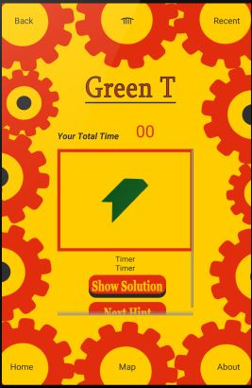

When all the hints are used, the visitor has the option to view the solution to the puzzles if they haven’t completed the puzzles yet.

Through the “Sounds and Visuals” button on the main screen, visitors again choose one activity from those listed. The “Animal Sounds” activity brings the visitor to a screen that informs the user of what the activity in the museum is, its relation and application in real life, as well as how to use the actual activity. The user can also press the “Play the Game!” button, which then transfers the user to the Animal Quiz app

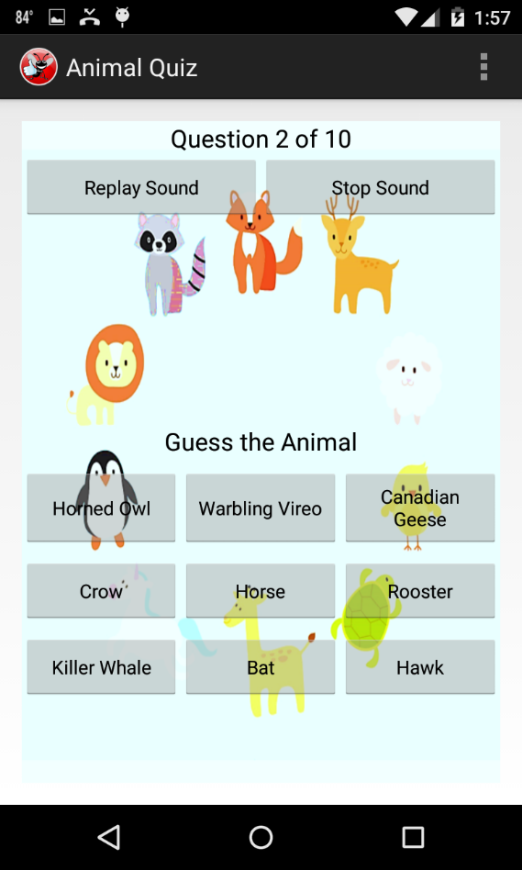

Through the “Physics” and “Technology” buttons on the main screen, the user can pick from a scroll view of activities available for exploration. Once clicked on one of the activities, the visitor can learn about what the activity is, “life hacks,” or its application in real world events, and how they can use, play, or learn with it.

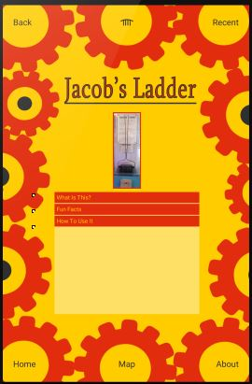

Discussion

In just the three weeks, our Gizmo City team was able to achieve much, however there is no doubt room for improvement and new, innovative additions in the future. The most obvious flaw in our app is that many of the informational pages are nonexistent or lacking real text. We have designed the graphics and layouts for each activity in the app and shot all of the pictures and videos in the museum however we are still lacking in that many of these pictures still need to be inserted into the app. In addition, the text and facts about some of the exhibits need to be written and inserted. Right now, many activities implement the same accordion view to display information, however in the future, we hope to vary the methods used to present fact, such as adding more games, or allowing the user to swipe between information pages. In the puzzles section, the possibilities with the timers are endless. We could add a greater amount of hints for each puzzle, implement a new game in which visitors could challenge friends and other visitors to complete certain puzzles within a given time, create a scoreboard to show which visitors have been the most successful at solving each of the puzzles, or create a round-robin type of game where entire classrooms or camp groups could compete to complete all of the puzzles with the highest score.

Conclusion

All in all, the Gizmo City team is incredibly pleased with what we have accomplished in the span of the last three weeks. During our first conceptualizations of our application at the Museum of Discovery and Science we had a clear purpose for the application and what role it would serve within the museum, and “Gizmo City” has met all of these expectations spectacularly. Our team is also proud to boast that we managed to incorporate all of our earliest plans for the application without having to simplify or remove the more difficult aspects, such as the timed hints and accordion-style text boxes. We feel very good about what we have accomplished, and look forward to seeing the future developments and uses of our application within the museum.

Acknowledgments

The Gizmo City team would foremost like to thank Florida Atlantic University for providing us with their “Mobile Applications for Google’s Android” class. Moreover, we would like to show our gratitude to Florida Atlantic University professors Ravi Shankar, Francis McAfee, and Diana Mitsoba-Boneva, as well as their teaching assistants Santiago Aguerrevere, Alain Edwards, and Demetrius Dukes, for providing us their instruction and guidance. We would like to show our gratitude to Fort Lauderdale’s Museum of Discovery and Science for granting us this amazing opportunity, as our application would be nonexistent if not for the museum’s “APP-titude” internship program. We would also like to thank museum employees Summer Scarlatelli and Joe Cytacki for being fantastic mentors and museum representatives, as well as backing the entire APP-titude team. Additionally, we would like to give reference to the novels *Hello Android* by Ed Burnette and *Android Studio Essentials* by Neil Smythe, as each were of great use when developing the Gizmo City application. Last but certainly not least, we would like to show our gratitude to the United Way of Broward County for sponsoring the APP-titude program and helping make all of this possible.

References

The Gizmo City team used the books “*Hello Android*” by Ed Burnette and "*Android Studio Essentials*" by Neil Smythe. Google Design was an inspiration for the icon concepts. Sounds from SoundBible.com were utilized and the FlagQuiz game was utilized as a template for their Animal Quiz game. Photoshop was used to create many of the graphics.